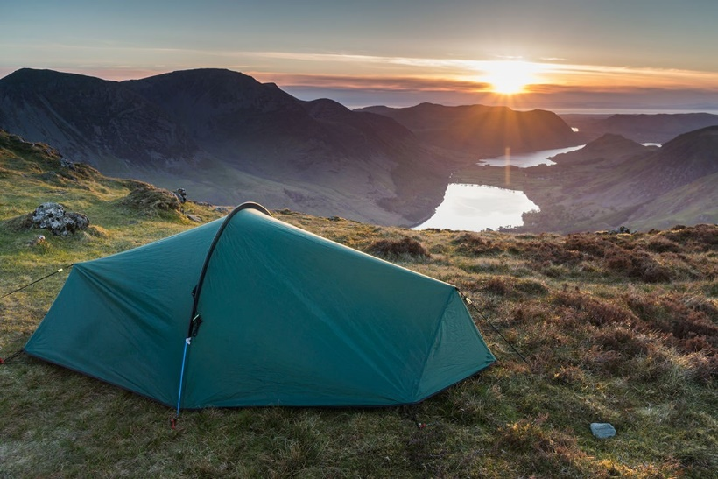
Adventure Solos: ADVENTURE LEADER ROLES
ROLE OPPORTUNITIES
adventure Solos: Share the adventure
www.adventuresolos.com
Adventure breaks Group Limited | Registered Number 12921217 Copyright 2019-2021

OPPORTUNITY: 2x ADVENTURE LEADER ROLES
Adventure Breaks Group Limited

ABOUT ADVENTURE SOLOS
Adventure Solos’ events are solo-friendly adventures. They are very social events. All of our guests are adults; most are in their 30s-50s, and they almost all book on by themselves. Our events are typically weekend events in and around the Lake District, or week-long events in Scotland. We have a loyal customer base, and we have big plans for the future. Chris, the founder of Adventure Solos, has a passion for the outdoors and has a background in funding growth businesses. Adventure Solos started trading in 2019 and is now a fast-growing company. Adventure Solos is a trading name of Adventure Breaks Group Limited. You can find out more about our events here: https://www.adventuresolos.com/

THE ROLES
We are currently looking for two outdoor instructors to run events on a freelancer basis as ‘Adventure Leaders’. The events are based in Scotland (5-day events, generally Monday to Friday). The primary events you would be running are:
- Caledonian Canal (Fort William to Inverness) canoe-camping events; and
- River Spey canoe-camping events.
​
These events are typically small groups of around 4-8 guests. The guests generally book on by themselves without knowing anyone else. This means a primary function of the role is to ‘host’ the guests. This includes helping to create a fun and friendly group dynamic, and would therefore be best suited to someone that is generous, gregarious and sociable. You do not generally need to 'baby-sit' customers (e.g. you do not need to cook for them or set up their tents each night etc). Instead, being able to build up rapport is vital in order to create the right group dynamic. We include an expense allowance so that you can fully participate with guests - for example to cover a drink and meal if the group is eating in a pub.
​
Base rate of pay is generally £750 for a 5-day trip (£150 per day) plus:
- participation in a bonus scheme (£200+ per week additional is very achievable);
- expense allowances.
​
There may also be opportunities to get involved in leading other events if you are suitably qualified, such as hiking the Yorkshire 3 Peaks Challenge, West Highland Way and East Highland Way events. Please mention this in your application if this would be of interest.

WHAT WE ARE LOOKING FOR
We are most interested in understanding any value-add beyond technical qualifications that you may be able to bring to Adventure Solos events. Specifically, a suitable candidate will be:
- Open, honest, reliable and dependable. These qualities are essential.
- Generous, gregarious and sociable. A key role is to create a fun and friendly dynamic between strangers.
- A problem solver. Things don’t always go to plan.

WHAT WE OFFER
We provide a fun and friendly working environment where you will be rewarded for helping us to succeed. We believe we offer a fair base rate of pay, plus the opportunity to earn significant performance related bonuses. Adventure Solos events are social adventures, and you are a key factor in creating the right dynamic on an event. Successful Adventure Leaders are able to earn significant bonuses.

PROCESS
Please complete an application form if you wish to be considered. Successful applicants will be invited to attend an interview (this may be online and/or in person).

HOW TO APPLY
To apply, please complete the application form below and email it to info@adventuresolos.com .
Application Form: Adventure Leader Roles

GENERAL
- Full names: [Enter text here.]
- Address: [Enter text here.]
- Contact email address: [Enter text here.]
- Contact telephone number: [Enter text here.]
- Do you have the legal right to work in the UK? [Enter text here.]
- Please tell us a little about yourself (in general, not necessarily all work related): [Enter text here.]

QUALIFICATIONS
- Do you hold any current and valid paddle-sport qualifications? [Enter text here.]
- Do you hold any current and valid First Aid qualifications? [Enter text here.]
- Do you hold a current and valid Mountain Leader qualification? [Enter text here.]
- Please specify any other relevant qualifications: [Enter text here.]

DRIVING (NOT PRE-REQUISITES)
- Do you have a full and valid UK driving licence? [Enter text here.]
- Do you have qualification to drive other people such as CPC (and if so, please specify the qualification)? [Enter text here.]
- Would you be comfortable towing a canoe trailer for events should the need arise (and if so, do you have a vehicle with a towbar)? [Enter text here.]

RECENT WORK HISTORY
- Please provide details of what you have been doing for work/with your time during the last 12 months, including dates. [Enter text here.]
- What are the key skills you need/use in your current role(s)? [Enter text here.]
- Is there anything else you would like to add? [Enter text here.]

PREVIOUS WORK HISTORY
- Please provide an overview of the key parts of your work history to date, with dates where appropriate (this experience may be outdoor related, a different career, raising a family and/or any other experience you feel may be relevant). If it is easier for you, you are welcome to send a CV through instead. [Enter text here.]
- What would the key points your most recent employer would say about you? [Enter text here.]
- What are the key skills you used in your historic role(s)? [Enter text here.]
- Is there anything else you would like to add? [Enter text here.]

SPECIFIC EXPERIENCE (DO NOT WORRY IF THE ANSWER TO THESE IS ‘NO’)
- Have you canoed the Caledonian Canal/Great Glen Way (Fort William to Inverness)? If so, approximately how many times, when was the last time, and were these ever as the sole/lead instructor? [Enter text here.]
- Have you canoed the River Spey? If so, approximately how many times, when was the last time, and were these ever as the sole/lead instructor? [Enter text here.]
- Please mention if you would be interested in leading other Adventure Break events [Enter text here.]

OTHER EXPERIENCE (THESE QUESTIONS ARE OPTIONAL)
- Please tell us about any other experience you feel may help you bring skills/value to this role. This can be anything (e.g. if you have worked in a different career/industry, have financial experience, built a social media following, have other relevant life experience etc). [Enter text here.]
- Do you currently run your own outdoor business? [Enter text here.]

ADVENTURE LEADER SUITABILITY:
We believe it is important to both yourself and ourselves to ensure that anyone we work with is confident that your personality type is well suited to creating fun dynamics on Adventure Solos events. This way you will enjoy your work, you can help us continue to grow and you will be rewarded for your success.
Specifically, a suitable candidate will be:
- Open, honest, reliable and dependable. These qualities are essential.
- Generous, gregarious and sociable. A key role is to create a fun and friendly dynamic between strangers.
- A problem solver. Things don’t always go to plan.
Do you believe the above describes your personality and abilities well, and that you will be successful in creating good group dynamics? [Enter text here.]
Is there anything else you would like to add? [Enter text here.]

OTHER QUESTIONS:
- If you could suggest one improvement to the Adventure Solos website, what would it be? [Enter text here.]
- Do you use any social media channels in a work-related manner? Eg Instagram/Facebook. If you’re happy to share the details of any such accounts, please do so here. [Enter text here.]
- In the event of you being unsuccessful for a role at this time, would you like us to keep a copy of your records on file for consideration for future roles? [Enter text here.]
- Is there anything else we should know or that you would like to add? [Enter text here.]

Finally, I wish to say thank you for taking the time to apply for a role with Adventure Solos. I wish you the very best of luck with your application, and we hope to be able to have some adventures with you soon.

Chris
Founder of Adventure Solos

